1. **How do I find my team’s burndown chart ?**

On the program menu item select Program Increment Progress

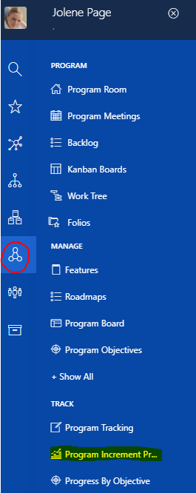

Make sure on the top left you have the correct ART selected , if not click on the program and click on the art name your project falls under

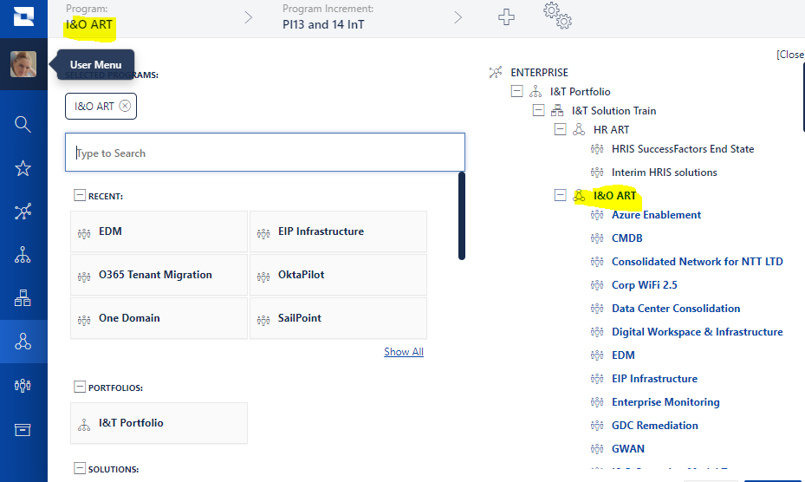

Top right click on Drill down



The Art Diagram will be displayed

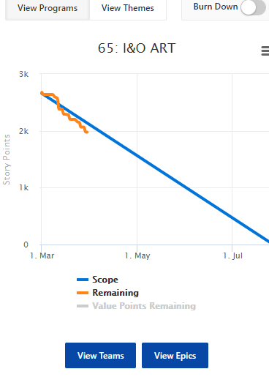

Select View Teams – all teams under the selected art will now be displayed with their burndown chart

1. **How do I view my program board for the PI ?**

1. **How do I find the team view to see team roles.**

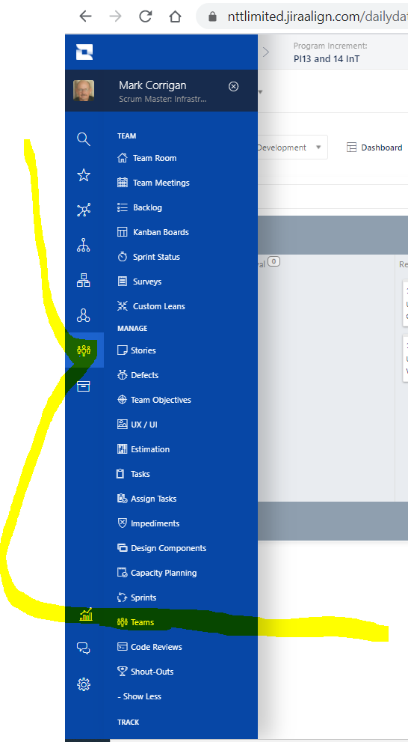

*Note: you may need to find +Show All (there are a few of them) and expand this if you cannot see Teams. Also you may need to resize the screen to under 100% to see everything on the menu in the image above if you cannot find what you are looking for*.

1. **How to open and close a sprint.**

**NB Do this only under exceptional purposes!!!**

**You may need to open a closed sprint to get at stories that are stuck in closed but are not completed or etc.**

Teams -> +Select More -> Sprints

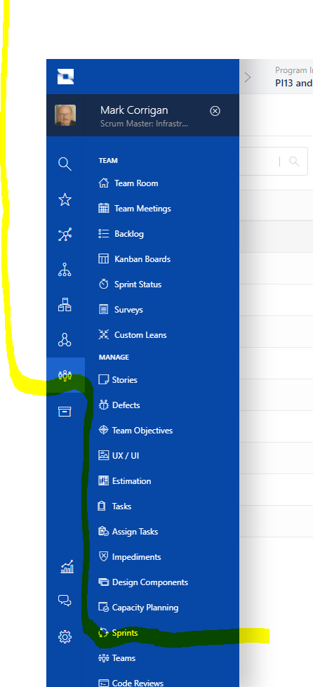

Find closed sprints using the Previous and Next buttons.

Click hyperlink on name of closed sprint.

Click + Full Details

Find State and then toggle and move from closed to in dev or other status. **Remember to close it again!!!**

1. **How to get a spreadsheet of Features and Stories from Jira Align**

​

Go to Team -> Stories

​

Apply Filter and select Program Increment.

​

Using filter continue and select PI and Team

then under More Actions export it.

When you have the spreadsheet downloaded note the following:

1. I select the User Stories tab at the bottom of the spreadsheet. Then delete rows 1 to 4.

1. Then I find Parent ID and Parent Feature and cut these columns and I put these at the left of my spreadsheet.

My goals is to sort the spreadsheet so that.

Feature 1

User Story 1

User Story 2

Etc.

Feature 2

User Story 1

User Story 2

Etc.

To sort by Parent Feature to achieve Feature 1

User Story 1

User Story 2

Etc.

Feature 2

User Story 1

User Story 2

Etc.

You may need to do another sort where you sort by Sprint.

​